**Creating users in Jenkins**

===========================

1. Open the dashboard of jenkins
2. Click on manage jenkins
3. Click on manage users
4. Click on create users
5. Enter user credentials

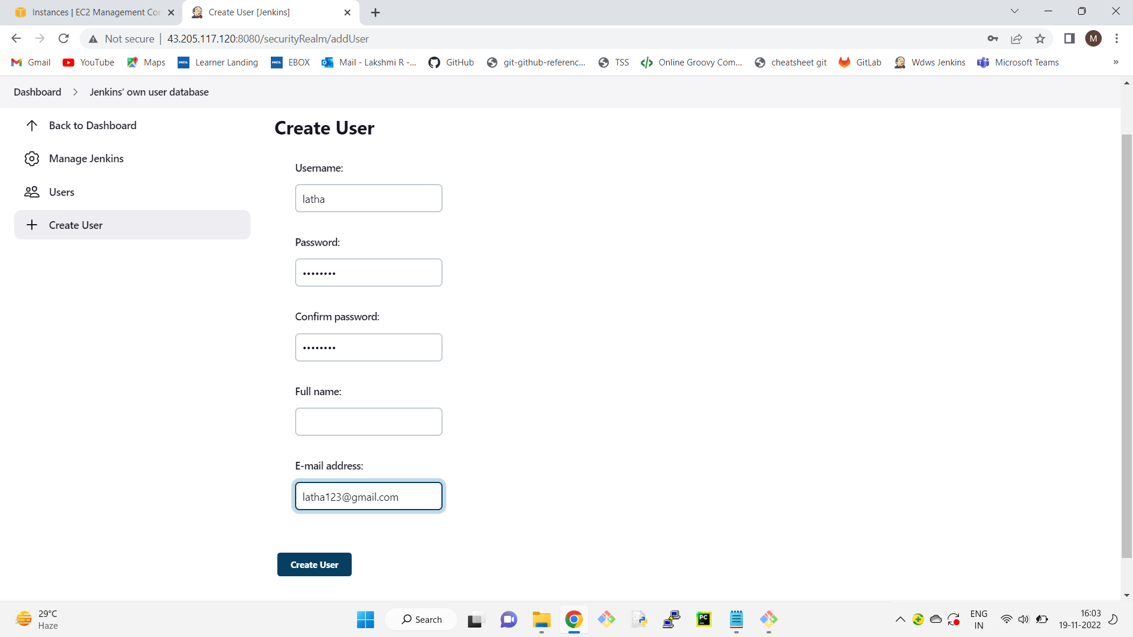

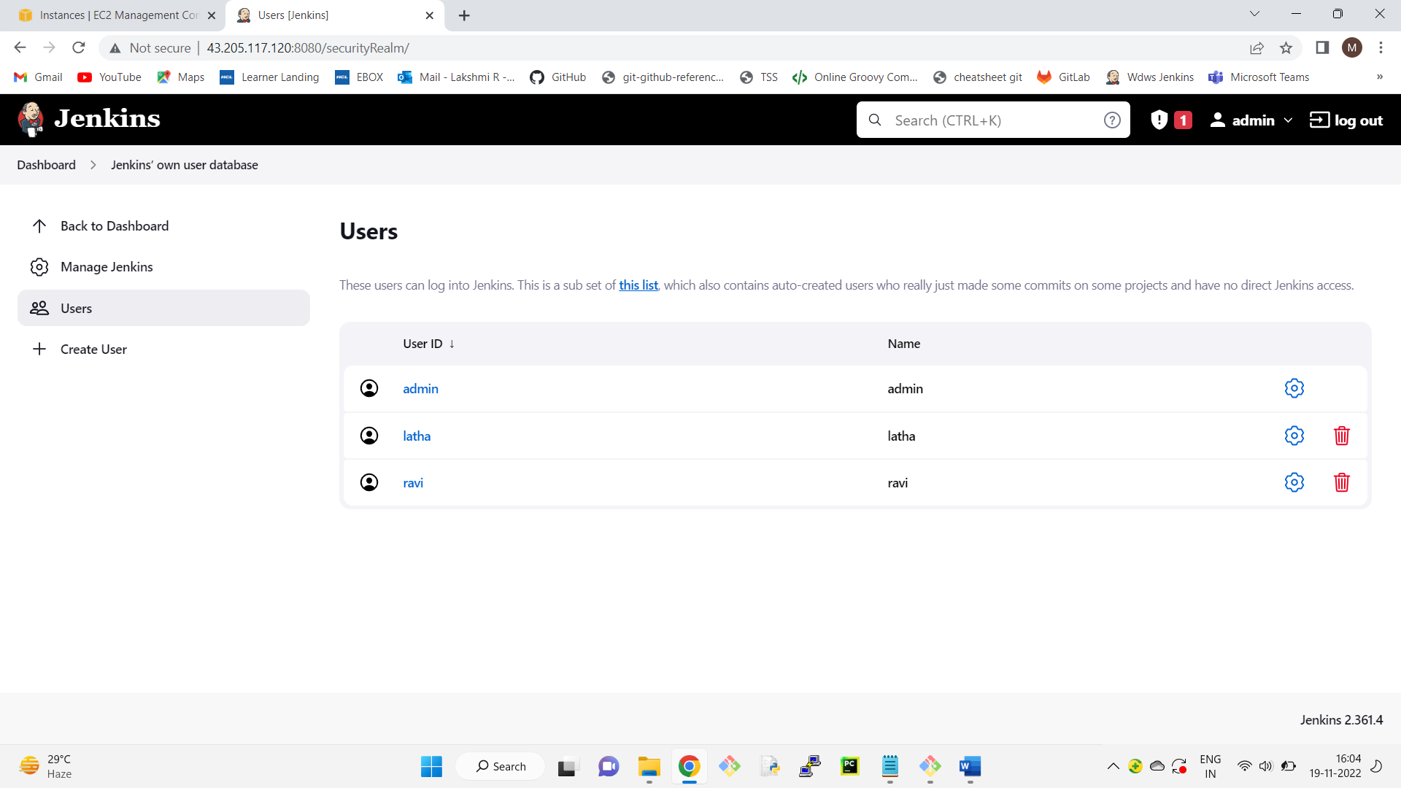

Creating roles and assgning

==============================

1. Install "role based authorization strategy" plugin

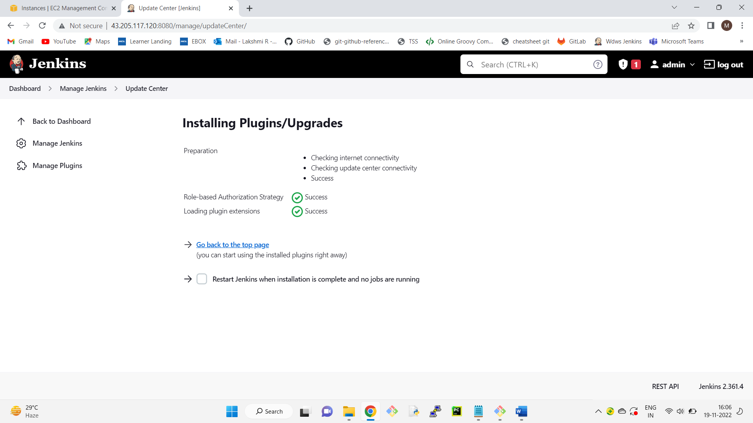

1. go to dashboard-->manage Jenkins
2. click on configure global security
3. Check enable security checkbox
4. go to authorization section-->click on role based strategy radio button
5. apply-->save

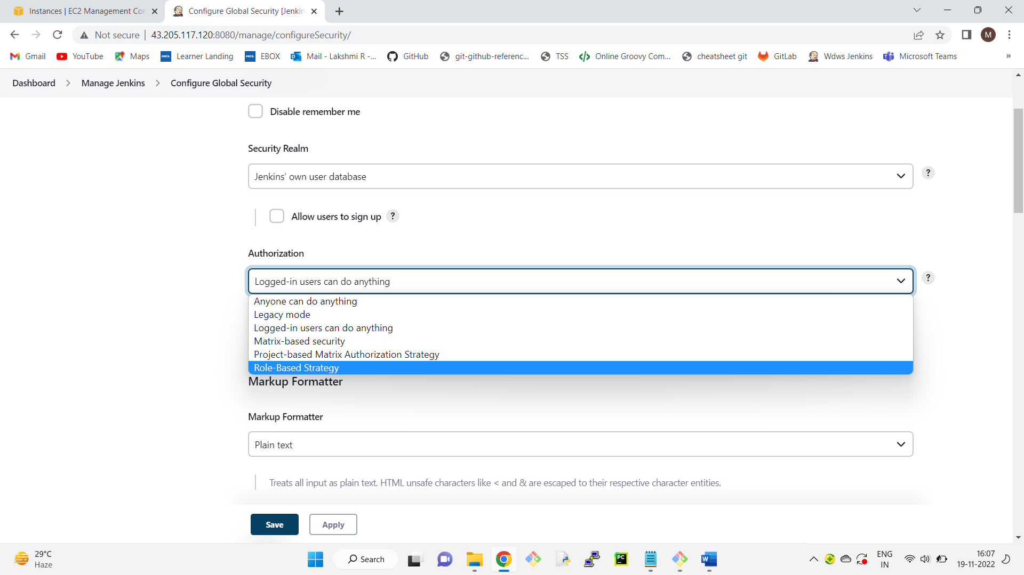

1. go to dashboard of Jenkins
2. click on manage Jenkins
3. click on manage and assign roles
4. click on mange roles
5. go to global roles and create a role "employee"
6. for this employee in overall give read access

in view section give all access

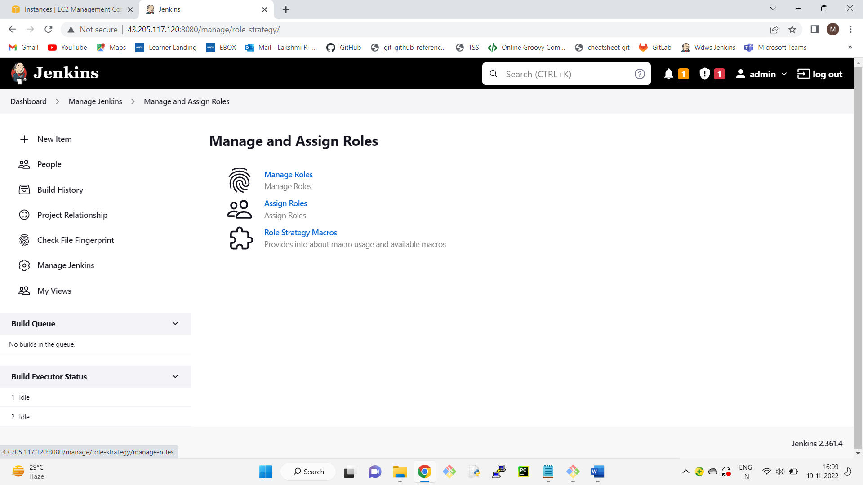

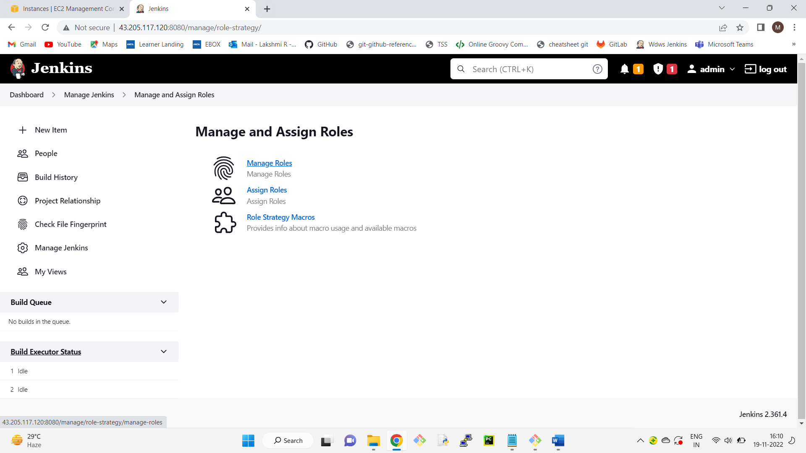

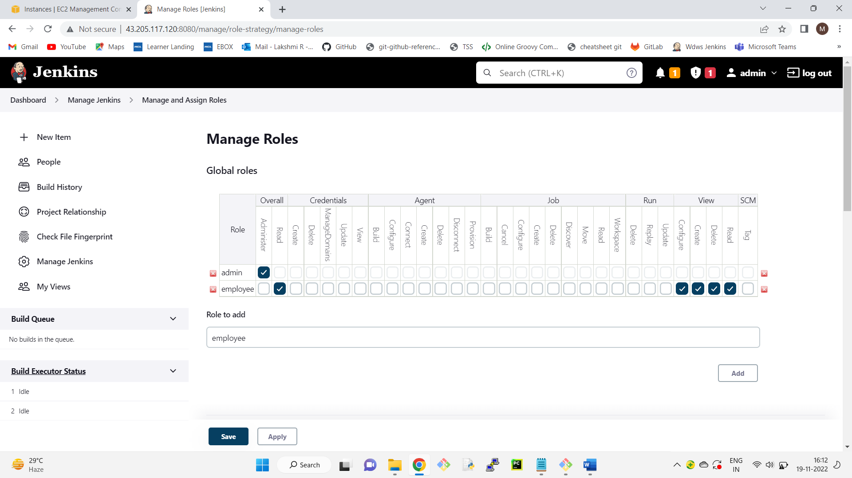

1. go to project roles-->Give the role as developer and patter as dev.* (ie developer role can access only those jobs whose name start with dev)
2. similarly create another role as tester and assign the pattern as "test.*"
3. give all permissions to developers and tester
4. apply—save

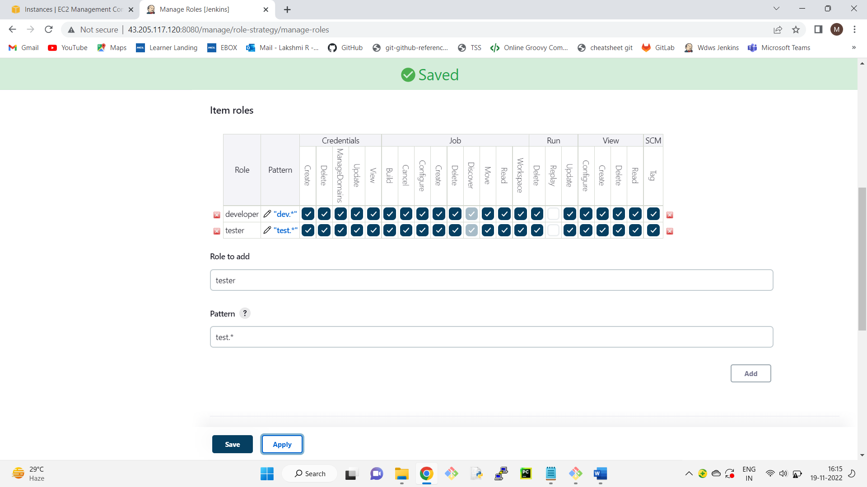

1. click on assign roles
2. go to global roles and add user1 and user2
3. check user1 and user2 as employees
4. go to item roles
5. add user1 and user2
6. check user1 as developer and user2 as tester
7. apply-->save

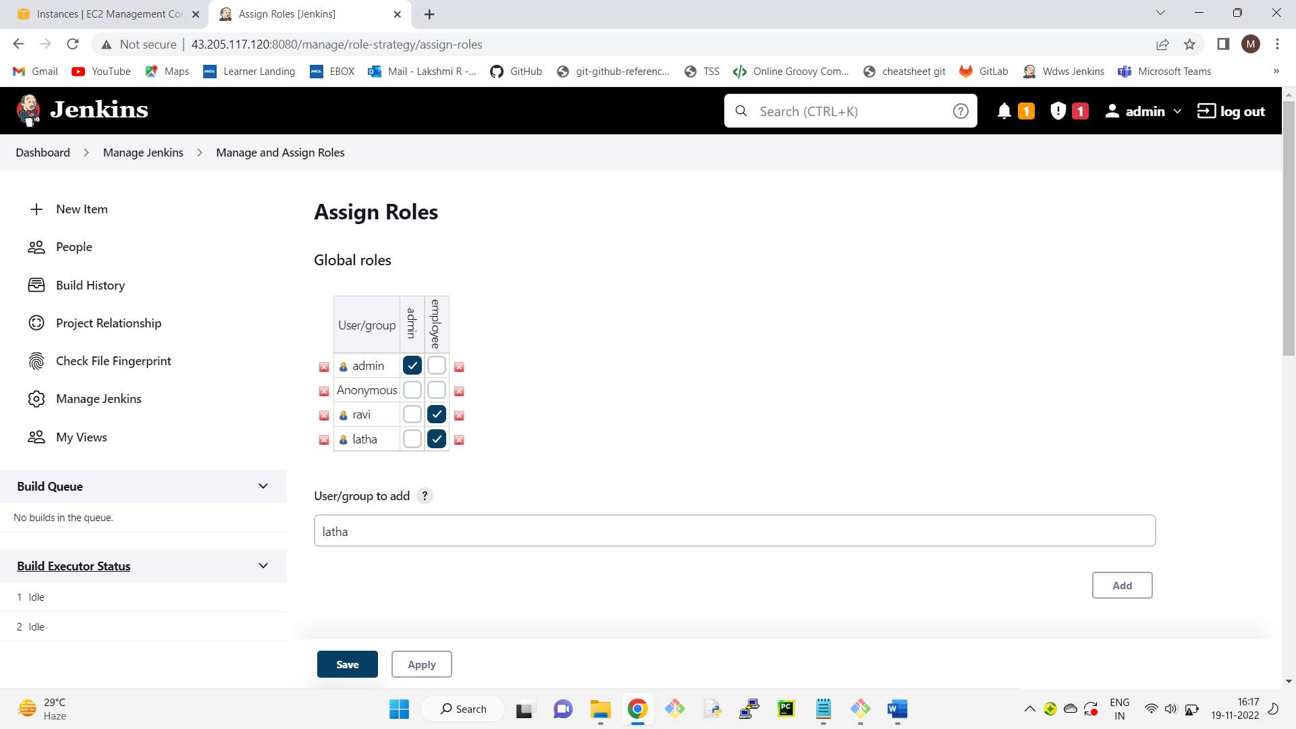

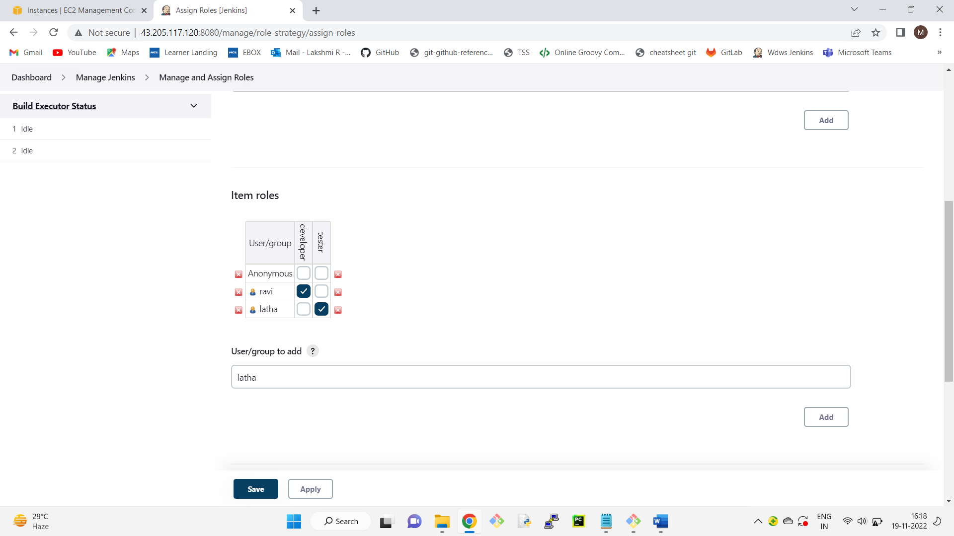

Restart Jenkins

http://13.233.127.59:8080/restart

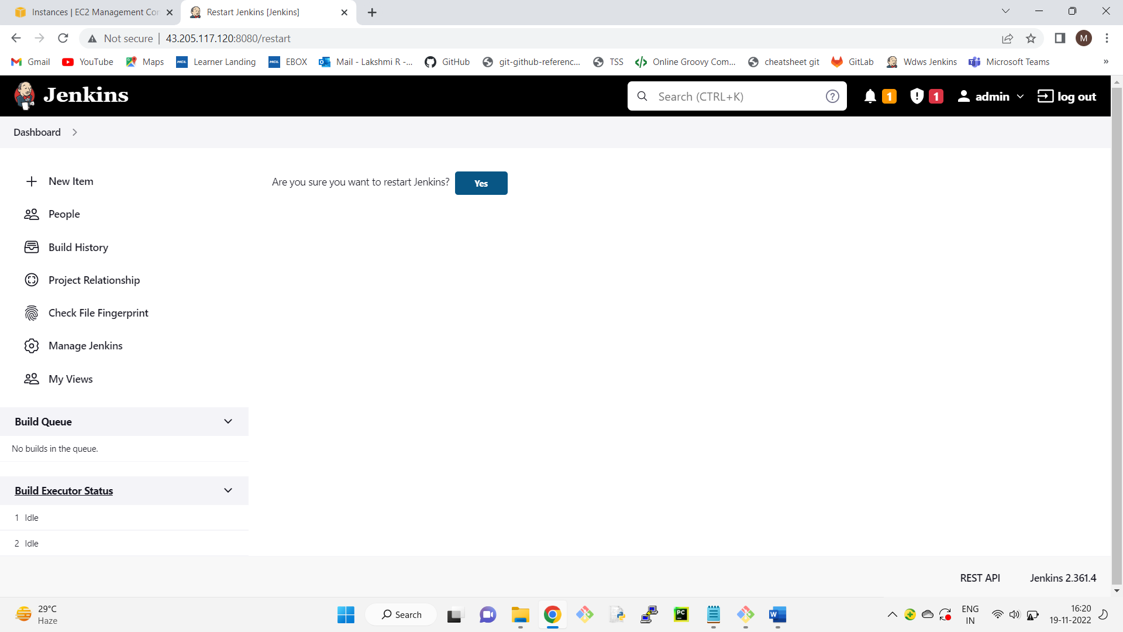

If we login into jenkins as user1 we can access on the development related jobs and user2 can access

only the testing related jobs

